1. Selenium Grid hub is launched. Three notes are registered on 5556, 5557, 5558 ports.

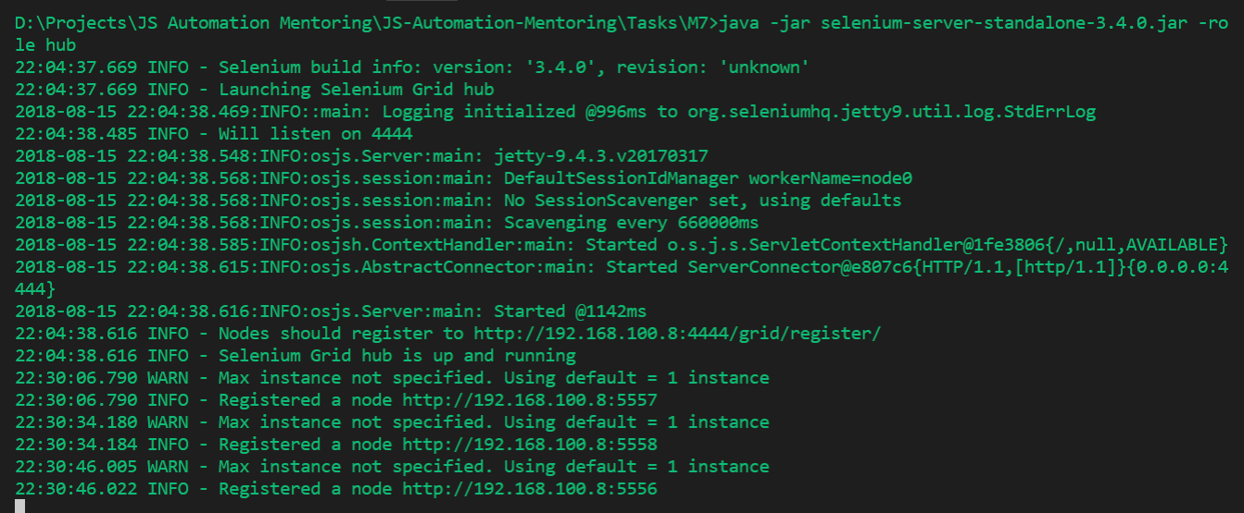

1. Registered nodes available at grid page.

